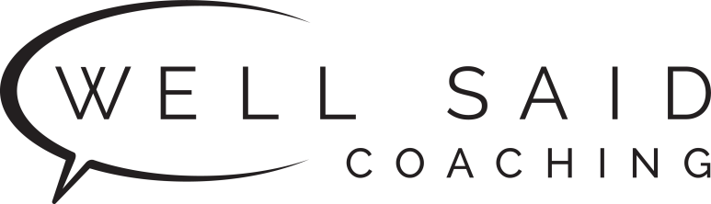

Current Rates

Private Speaking/Conversation Lessons
- Hourly Rate: $40/hour
- Packages are billed in 2 installments, or 10% SAVINGS* if you pay in full

Number of Hours | Price*  (paid in 2 installments) | Pay in full and save 10%! | Expiration**
8 Hours | $320 | $320 $288 | 3 months from date of your first lesson
12 Hours | $480 | $480 $432 | 4 months from date of your first lesson
** For example, if your first lesson is on April 1, you must complete your last lesson by July 1 (for the 8 hour package) or August 1 (for the 12 hour package).

All Packages Include
- Assessment
- 1-to-1 Private Lessons
- All materials, practice and homework.
- Your choice of location: online or Alameda, CA.

Billing
- Payment is expected at time of billing before the assessment and lessons begin.
- If you select full payment, one invoice will be sent.
- If you select two payments:
  - One invoice will be emailed to you before the first lesson; the second invoice will be sent to you halfway through your lessons. For example, if you signed up for 8 lessons, you will receive an invoice before your first lesson and before your fifth lesson.
- The invoice will contain a link to a secure payment page.
- Credit cards accepted include Visa, MasterCard, American Express, Discover, Diners Club, JCB and UnionPay. Alipay is also accepted.

Cancellation/Rescheduling
- If you need to cancel, it is your responsibility to notify Well Said Coaching at least 24 hours in advance of the scheduled sessions.
- If you cancel your session at least 24 hours in advance, you may reschedule that session until the expiration date of your package.
- We know emergencies happen! So you are allowed to cancel with less than 24 hours’ notice one (1) time and reschedule at no cost.
- If you cancel less than 24 hours in advance more than once, you can reschedule the session, but you will need to re-pay for it.

For example:

If You Cancel Your Session: | Policy:
More than 24 hours in advance  or  Less than 24 hours in advance (the first time) | You can reschedule the session at any time before your package expires at no cost.
Less than 24 hours in advance  (the second time, etc.) | You can reschedule the session at any time before your package expires, but you will need to re-pay for the session.

